**Computer Applications Technology**

Covid-19 has cost the corporate sector a lot of money. As a result of the declaration of Covid-19 as a pandemic, the country was shut down and a lockdown was imposed to protect the residents of South Africa. My research focuses on how the corporate sector will use ICT to generate revenue while adhering to COVID-19 laws. The purpose of this analysis is to assess how innovative ICT solutions evolved in response to Covid-19, as well as how businesses reacted to these changes.

**Unlocking a resilient future**

corporate sector

**Riya Ramesh Patel**



**Shree bharat sharda mandir**

**Grade 12A**

Table of Contents

Table of figures 1

Introduction 2

Focus Question 2

Discussion and analysis 3

Impact 3

Background 3

Solution 4

Costs 4

Findings 5

Conclusion 9

Bibliography 10

Appendices A

Addendum 1 -Folder structure A

Addendum 2- Source Table B

Addendum 3 -Declaration 11

[Phase 2 Spreadsheet](../../Phase%202/Spreadsheet)

[Phase 2 Database](../../Phase%202/Spreadsheet)

# Table of figures

Figure 1: Graph representing the different types of ICT tools used 6

Figure 2: Graph representing the total monthly and average cost for wifi 7

Figure 3: Graph representing the ratings of the performance of the internet connection 8

Figure 4: Graph representing issues with the internet and administrative processes 9

Figure 5 Sources and questions table M

# Introduction

Since COVID-19 is a health crisis, employers has taken responsibility for keeping their workforce safe and ensuring their people and customers aren't put at risk of infection. The lockdown regulations has had a negative impact on the corporate sector, and many businesses were forced to close because they were unable to exit due to the regulations. Keeping people safe and healthy should be the objective for employers getting back to work during this health crisis, but companies focussed on how they can maintain a productive, sustainable workforce that allowed them to stay competitive with the use of technology. Organizations adapted quickly to these developments, which in turn has more pressure on supply chains to be responsive.

This can be done enhancing the customer service, provide ongoing training, to improve organizations reactivity to new changes, to change the basis of competition and the overall performance, open lines of communication. Sales have increased as a result of providing and acquiring goods and services online. It has given clients access to a wide range of products from the comfort of their own homes, and it has allowed businesses to continue operating despite contact restrictions and other quarantine procedures.

The purpose of this analysis is to assess how innovative ICT solutions evolved in response to Covid-19, as well as how businesses reacted to these changes. Some research has been conducted to analyse how the corporate sector was adapting by doing things differently. The focus of my PAT research was on ICT in the corporate sector and other solutions in response to the COVID-19 pandemic. The investigation focussed towards how the corporate sector used ICT by adapting to current situations such as the COVID-19 pandemic. I prepared a report using research/information acquired from the internet and through surveys.

# Focus Question

What improvements can be made in the corporate sector using solutions and tools that are ICT driven to mitigate the effects of Covid-19?

# Discussion and analysis

### Impact

To ensure the safety of its employees and the security of its productive assets companies would need to define new working arrangements and reimagine business as normal while simultaneously adhering to local labour laws and prioritizing employee health and safety. (GLOBAL, 2020). Modes of technology to assess possible threats and determine responses would be ABCD Crisis Intervention, Critical Incident Stress Management (CISM), NOVA Crisis Intervention. (Wiese, 2017). The effect of demand disruption on the rate of the data stored on computers can be solved by investing in protective gear for supply-chain workers and communicating via apps to manage time, availability and safety. Working closely with existing suppliers while diversifying the supply base. (Gattone, 2020). Methods of technology can be used to identify the supply chain and development risks that a crisis could bring by improving your cyber supply chain risk management.  Important for organizations to mitigate, manage, and handle risk in their supply chain if they want to ensure customer satisfaction, experience greater profitability and outcompete competitors. Manage environmental risk in your supply chain. (Moosa, 2017)

### Background

To maintain safe cash flows and long-term financing on an electronic device, you should always prioritize cash flow strategies in your business planning. Don't wait to send invoices. Adjust your inventory as needed. Re-evaluate your business operations. (Schooley, 2020). If the company has crisis management teams in place to deal with short-term liquidity issues and implement effective countermeasures using technology that can be assessed by the likelihood of a particular crisis occurring - and its possible frequency. Determining its possible impact on the operations. (Dorothee, 2020).

### Solution

To ensure consistent and open communication with all stakeholders, companies would need to define new working arrangements and reimagine business as normal while simultaneously adhering to local labour laws and prioritizing employee health and safety. (GLOBAL, 2020). The effects of a recession and dealing with future crises with regards to technology: Identify ways to capitalize on the downturn in the longer term, partly by exploiting the mistakes of less savvy rivals, customer’s priority, marketing strategy, developing innovative practices (John Qeulch, 2020)

### Costs

The effects of a crisis in digital budgeting and business planning processes, as well as incorporated early warning systems would be by treating a budgeting process, the benefits. Things to consider would like what’s the annual plan? Using the budget to measure performance Identify potential crises that might affect you. Determine how you intend to minimise the risks of these disasters occurring. Set out how you'll react if a disaster occurs in a business continuity plan. Test the plan regularly. (Carlan, 2020). To makes changes in your business using technology models to minimize costs in the short and medium term when a crisis has a major financial impact you can evaluate the supply chain. Get communication right. Use scenario analysis. Don’t lose sight of other risks. (Butler, 2020)

.

# Findings

Figure 1: Graph representing the different types of ICT tools used

According to the graph most people use Microsoft teams to communicate with each other. Microsoft Teams should be used by enterprises since it is incredibly user-friendly and may facilitate collaboration between remote users or inside a huge organization. Microsoft Teams can help with projects, productions, and other aspects of the business. Large volumes of data can be stored, processed, analysed, and shared via ICT systems. Managers and staff can make quick and accurate decisions using company data, allowing them to efficiently manage operations and respond quickly to business opportunities and risks.

Figure 2: Graph representing the total monthly and average cost for wifi

The total monthly cost for wifi is R27280 and the average cost R699.49. For a business the price depends on the type of connection (DSL, cable, or fibre), special features (like a dedicated line), and what speed you get. For personal use it the same as well. Depends on the type of connection, usage, the number of people connected to the wifi etc.

Figure 3: Graph representing the ratings of the performance of the internet connection

The graph shows most peoples rating for the performance of the internet is a 5 which is excellent. Many people nowadays have fibre connection. Fibre is the fastest internet currently accessible, with speeds up to 10,000 Mbps in some regions. It transmits light messages using bundled glass fibre-optic threads that are quick and dependable across long distances. Fibre is unaffected by the speed difficulties that plague earlier internet connections.

[More info refer to Spreadsheet.](../../Phase%202/Spreadsheet/Spreadsheet.xlsx)

Figure 4: Graph representing issues with the internet and administrative processes

The graph shows that many people did not have issues with the internet and they did have administrative processes done. A business administrator oversees the general operations of an organisation or department. This may include supporting and overseeing teams, problem solving, developing and implementing plans, and meeting goals. People may not have issues with the internet because they may have good quality of internet connection, a good source of internet.

# Conclusion

A study was carried out to see how the corporate sector was adjusting by doing things differently. My PAT study focused on ICT in the workplace and other solutions in response to the COVID-19 epidemic. The inquiry looked on how businesses used ICT to respond to current events such as the COVID-19 outbreak.

Companies would have to define new working arrangements and rethink business as usual to protect the safety of their employees and the security of their productive assets while also conforming to local labour rules and emphasizing employee health and safety. The benefits of treating a budgeting process would be through addressing a crisis in digital budgeting and company planning processes, as well as integrating early warning systems. If the organization has crisis management teams in place to cope with short-term liquidity concerns, effective technology-based on countermeasures can be applied.

Sales have increased as a result of providing and acquiring goods and services online. It has given clients access to a wide range of products from the comfort of their own homes, and it has allowed businesses to continue operating despite contact restrictions and other quarantine procedures. To tackle COVID-19, many businesses have devised intuitive, unique, and creative solutions. In addition, there are regulations and restrictions in place to ensure that no employee or consumer is harmed by a virus. They worked efficiently using online tools such as Microsoft Teams, Zoom, Skype and others. My inquiry was a success since I was able to use data gathered through surveys and turn it into relevant information.

# Bibliography

Abudi, G. (2013, August 9). Retrieved April 10, 2021, from Managing communications effectively and efficiently: https://www.pmi.org/learning/library/managing-communications-effectively-efficiently-5916

Butler, M. (2020, March 6). Retrieved April 12, 2021, from Strategy+ Business: https://www.strategy-business.com/blog/Seven-key-actions-business-can-take-to-mitigate-the-effects-of-COVID-19?gko=4c0d1

Carlan, J. (2020, January 11). Retrieved April 11, 2021, from Info entrepreneurs: https://www.infoentrepreneurs.org/en/guides/budgeting-and-business-planning/

Dorothee, A. (2020, November 10). *OECD*. Retrieved April 13, 2021, from https://www.oecd.org/coronavirus/policy-responses/the-territorial-impact-of-covid-19-managing-the-crisis-across-levels-of-government-d3e314e1/

Gattone, M. (2020, March 17). Coronavirus and Supply Chain Disruption: What Firms Can Learn.

GLOBAL, E. (2020, March 19). Retrieved April 12, 2021, from Covid-19 pandemic and planning: https://www.ey.com/en_za/covid-19/covid-19-and-pandemic-planning--how-companies-should-respond

John Qeulch, K. J. (2020, April 5). How to market in downturn. Business Review .

Moosa, N. (2017). Info entrepreneurs.

Schooley, S. (2020, December 23). Business News Daily. Business News .

Wiese, T. (2017). *Corporate governance in South Africa.* Juta and Co.

# Appendices

## Addendum 1 -Folder structure

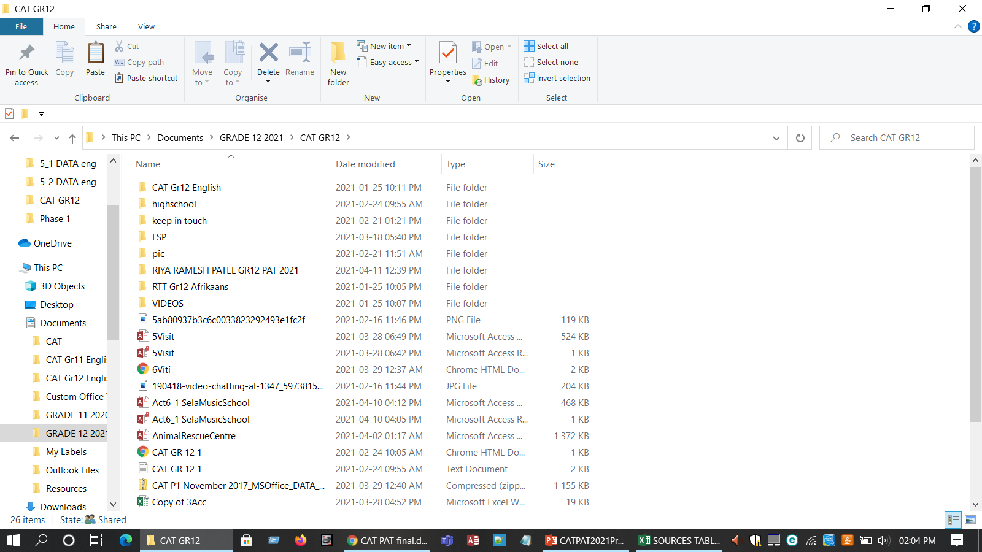

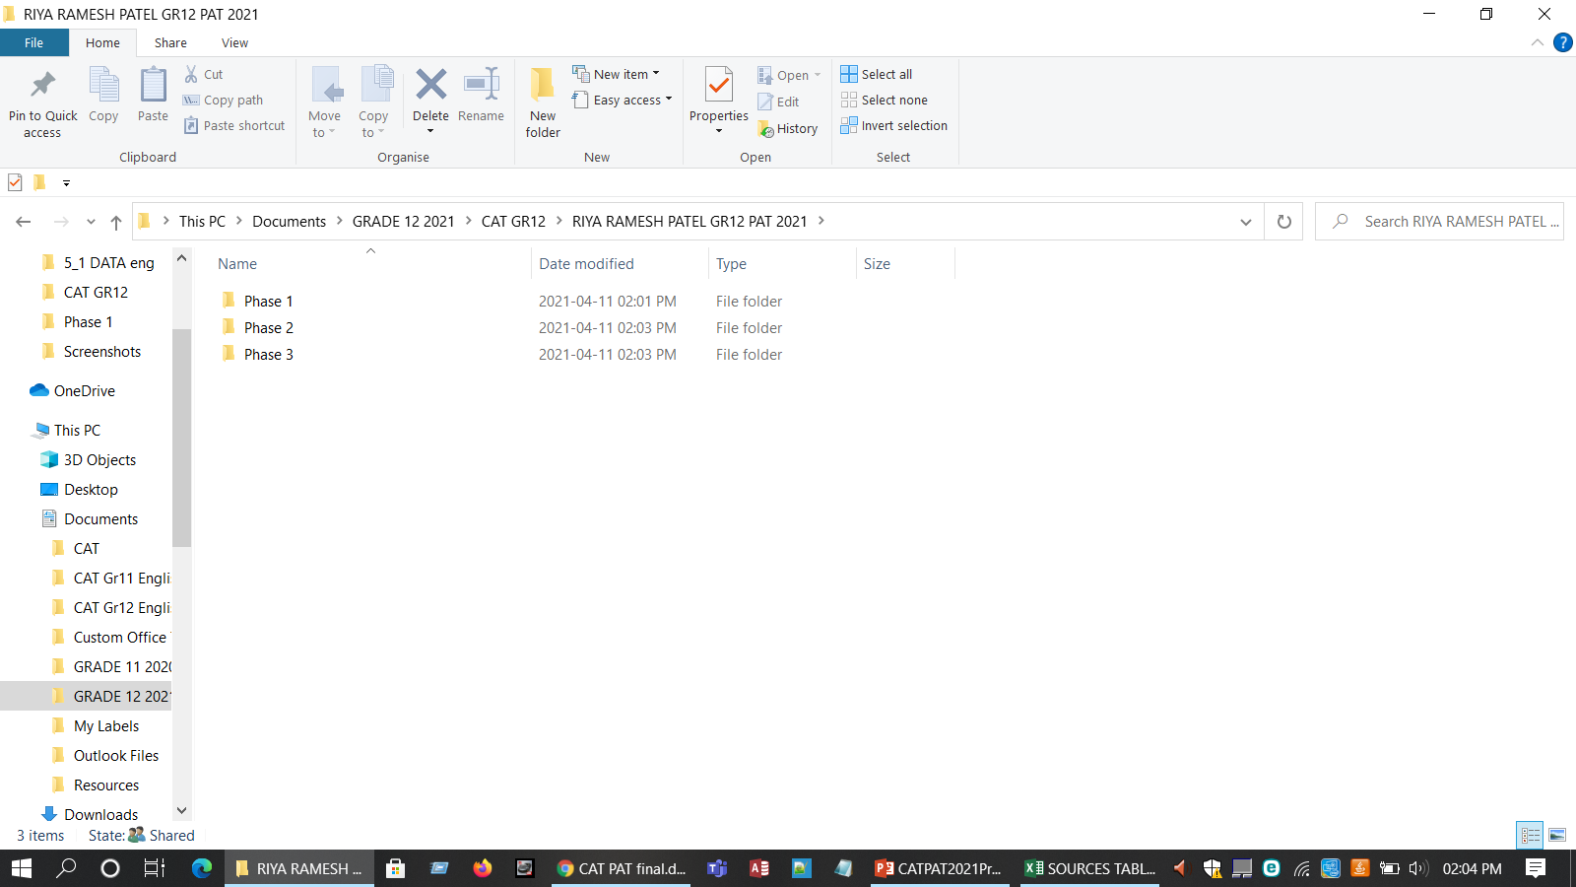

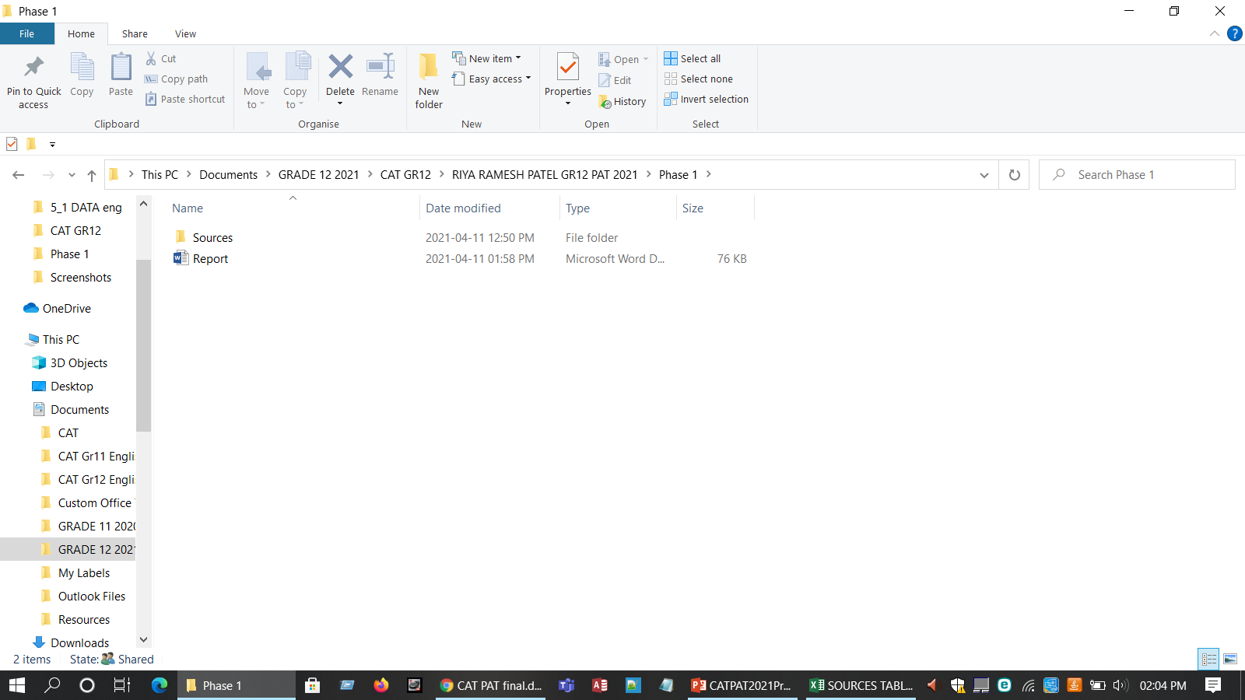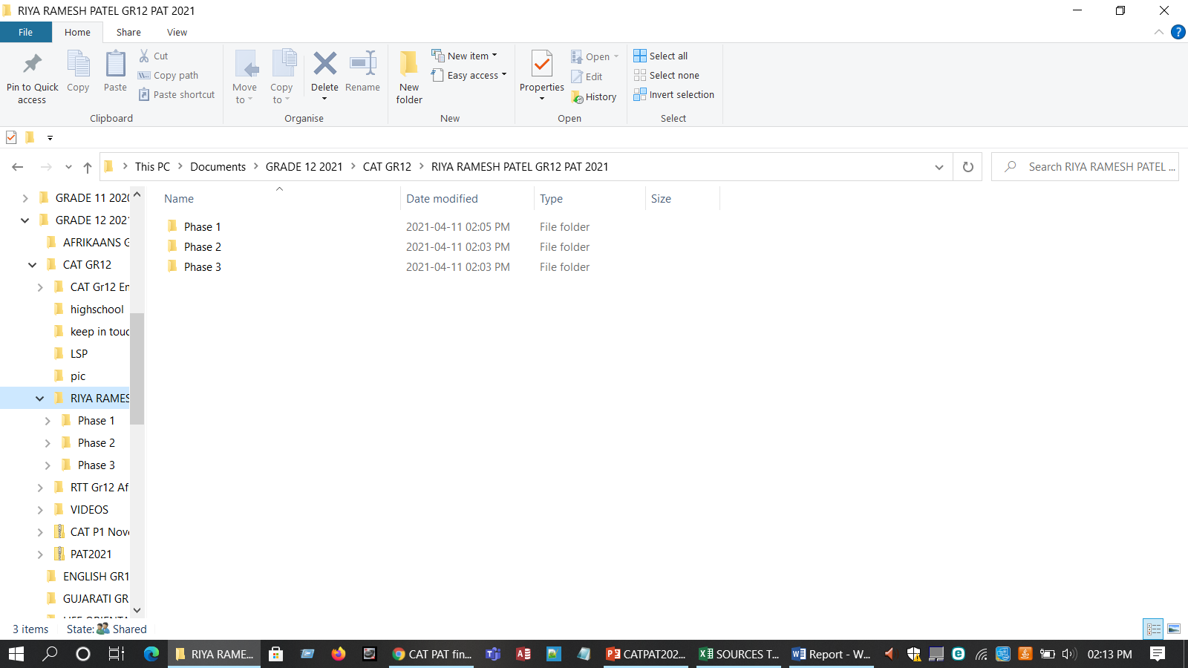

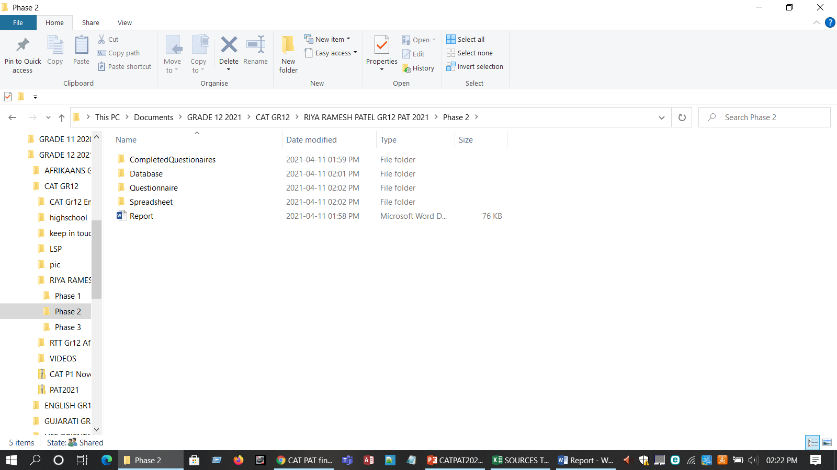

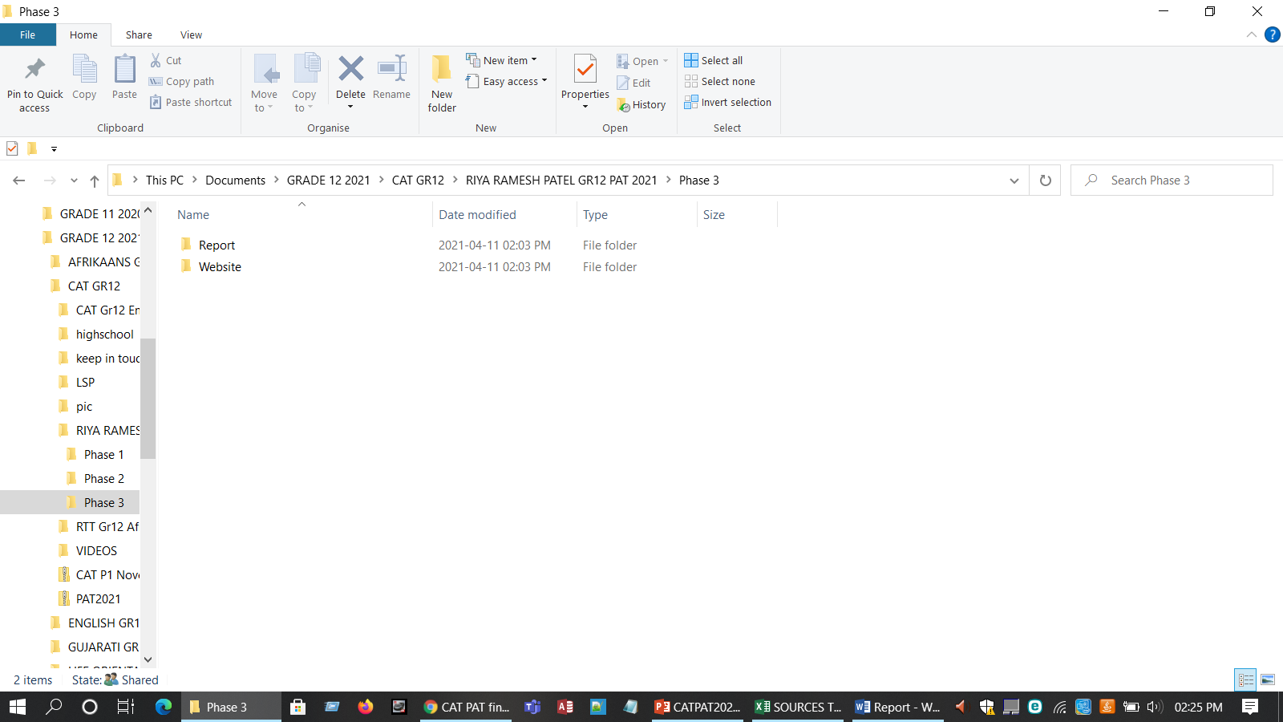

## Addendum 2- Source Table

|  |  |  |  |  |  |  |  |  |  |  |
| --- | --- | --- | --- | --- | --- | --- | --- | --- | --- | --- |
| **NO.** | **QUESTION** | **QUESTION LEVEL (1,2,3,4)** | | **CATEGORY** | **TYPE OF SOURCE** | **BIBLIOGRAPHICAL INFORMATION** | | **QUALITY OF INFORMATION FOUND** | | **SUMMARY OF INFORMATION FOUND** |
|
|  |  |
| **1** | In the event of a crisis, using ICT tools how can your company ensure the safety of its employees and the security of its productive assets? | 1 | | Impact | **Internet** | **Authors(s)** | EY Global | **Authority** | The author is from a Multidisciplinary professional services organization | Companies would need to define new working arrangements and reimagine business as normal while simultaneously adhering to local labour laws and prioritizing employee health and safety. (GLOBAL, 2020) |
| **Name of website/ web page** | Covid-19 pandemic and planning | **Currency** | This was published on the 19 of March 2020 |
| **Date created/updated** | 19-Mar-20 | **Accuracy** | The information provided corresponds with the current trends |
| **Date accessed** | 12-Apr-21 | **Objectivity** | The source is free of bias, and all of the information is accurate. |
| **URL** | https://www.ey.com/en_za/covid-19/covid-19-and-pandemic-planning--how-companies-should-respond | **Coverage** | The article goes into a lot of different systems. |
| **2** | How do you maintain safe cash flows and long-term financing on an electronic device? | 2 | | Background | **Magazine** | **Author(s)** | Skye Schooley | **Authority** | The author assists in dealing financial problems in the business | You should always prioritize cash flow strategies in your business planning. Don't wait to send invoices. Adjust your inventory as needed. Re-evaluate your business operations. (Schooley, 2020) |
| **Title** | Business News Daily | **Currency** | This was published on the 23 of December 2020 |
| **Date published** | 23-Dec-20 | **Accuracy** | The data presented is consistent with current trends. |
| **Publisher** | Business news | **Objectivity** | There is no prejudice in the source and all the information is true |
|  |  | **Coverage** | The article covers a broad range of programs. |
| **3** | Are communication processes and procedures well-coordinated and structured to ensure consistent and open communication with all stakeholders? | 4 | | Solution | Website | **Authors** | Abudi, Gina | **Authority** | They plan for stakeholders in projects |  |
| **Name of website** | Managing communications effectively and efficiently | **Currency** | This was published on the 10 of April 2021 | Improving the effectiveness of communications overall, including frequency and quality. |
| **Date created** | 09-Aug-13 | **Accuracy** | The information provided corresponds with the current trends | Keeping individuals engaged in the initiative through open communications. |
| **Date accessed** | 10-Apr-21 | **Objectivity** | The source is free of bias, and all of the information is accurate. | Getting stakeholders involved in communications through enabling for more effective two-way conversations. (Abudi, 2013) |
| **URL** | https://www.pmi.org/learning/library/managing-communications-effectively-efficiently-5916 | Coverage | The article goes into a lot of different services that are available. |  |
| **4** | Does the company have crisis management teams in place to deal with short-term liquidity issues and implement effective countermeasures using technology? | 3 | | Background | Website | **Author(s)** | Dorothée ALLAIN-DUPRÉ | Authority | Author is from the OECD Centre on SMEs, Entrepreneurship, Regions and Cities |  |
| **Name of website** | OECD | Currency | This was published on the 10 f November 2020 |
| **Date created** | 10-Nov-20 | Accuracy | The data presented is consistent with current trends. | Assessing the likelihood of a particular crisis occurring - and its possible frequency. |
| **Date accessed** | 13-Apr-21 | Objectivity | There is no prejudice in the source and all the information is true | Determining its possible impact on your operations. (Dorothee, 2020) |
| **URL** | https://www.oecd.org/coronavirus/policy-responses/the-territorial-impact-of-covid-19-managing-the-crisis-across-levels-of-government-d3e314e1/ | Coverage | The article goes into a lot of different systems. |  |
| **5** | In the event of a crisis, what mode of technology do you use to assess possible threats and determine responses? | 3 | | Impact | Book | **Author(s)** | Tobie Wiese | Authority | Author addresses the changes in the corporate governance landscape in South Africa |  |
| **Title of source** | Corporate governance in South Africa- book | Currency | This was published on the 26 of February 2017 | ABCD Crisis Intervention. |
| **Date published** | 26-Feb-17 | Accuracy | The information provided corresponds with the current trends | Critical Incident **Stress** Management (CISM) |
| **Publisher** | Juta and Co | Objectivity | There is no prejudice in the source and all the information is true | NOVA Crisis Intervention. (Wiese, 2017) |
|  |  | Coverage | The article covers a broad range of programs. |  |
| **6** | Have you factored in the effects of a crisis in digital budgeting and business planning processes, as well as incorporated early warning systems? | 4 | | Costs | Website | **Author(s)** | Jady Carlan | Authority | She is a well-known business manager | Treating a budgeting process. The benefits. What’s the annual plan? Using the budget to measure performance |
| **Name of website** | Info entrepreneurs | Currency | This was published on the 26 of February 2017 | Identify potential crises that might affect you |
| **Date created** | 11-Jan-20 | Accuracy | The data presented is consistent with current trends. | Determine how you intend to minimise the risks of these disasters occurring |
| **Date accessed** | 11-Apr-21 | Objectivity | There is no prejudice in the source and all the information is true | Set out how you'll react if a disaster occurs in a business continuity plan |
| **URL** | https://www.infoentrepreneurs.org/en/guides/budgeting-and-business-planning/ | Coverage | The article goes into a lot of different services that are available. | Test the plan regularly. (Carlan, 2020) |
| **7** | How do you change your business using technology models to minimize costs in the short and medium term when a crisis has a major financial impact? | 3 | | Costs | Website | **Author(s)** | Melanie Butler | Authority | She is a forensic accountant by background, she leads PwC’s Global Crisis Centre. She led the firm’s response to the 2013–16 Ebola outbreak in West Africa. | Evaluate the supply chain. Get communication right. Use scenario analysis. Don’t lose sight of other risks. (Butler, 2020) |
| **Name of website** | Strategy+Business | Currency | This was published on the 6 of March 2020 |
| **Date created** | 06-Mar-20 | Accuracy | The information provided corresponds with the current trends |
| **Date accessed** | 12-Apr-21 | Objectivity | The source is free of bias, and all of the information is accurate. |
| **URL** | https://www.strategy-business.com/blog/Seven-key-actions-business-can-take-to-mitigate-the-effects-of-COVID-19?gko=4c0d1 | Coverage | The article goes into a lot of different systems. |
| **8** | How will demand disruption affect the rate of the data stored on computers? | 2 | | Impact | Article | **Author(s)** | Michael Gattone | Authority | He is a well know planner in the business | Invest in protective gear for supply-chain workers and communicate via apps to manage time, availability and safety. Work closely with existing suppliers while diversifying the supply base. (Gattone, 2020) |
| **Title of source** | Coronavirus and Supply Chain Disruption: What Firms Can Learn | Currency | This was published on the 17 of March 2020 |
| **Date published** | 17-Mar-20 | Accuracy | The data presented is consistent with current trends. |
| **Publisher** | Business Daily | Objectivity | There is no prejudice in the source and all the information is true |
|  |  | Converge | The article covers a broad range of programs. |
| **9** | With what methods of technology can be used to identify the supply chain and development risks that a crisis could bring? | 3 | | Impact | Article | **Authors** | Numra Moosa | Authority | She works in a supply development country |  |
| **Title** | Info entrepreneurs | Currency | This was published in 2017 | Improve your cyber supply chain risk management. |
| **Date published** | 2017 | Accuracy | The information provided corresponds with the current trends | Important for organizations to mitigate, manage, and handle risk in their supply chain if they want to ensure customer satisfaction, experience greater profitability and outcompete competitors. |
| **Publisher** | Kindle edition | Objectivity | There is no prejudice in the source and all the information is true | Manage environmental risk in your supply chain. (Moosa, 2017) |
|  |  | Coverage | The article covers a broad range of programs. |  |
| **10** | Is your business model stable enough to rebound from the effects of a recession and deal with future crises with regards to technology? | 3 | | Solution | Magazine | Author(s) | John Qeulch , Katherine Jocz | Authority | The author assists in helping others to deal with problems in the future |  |
| Title of source | How to market in downturn | Currency | This was published on the 5 of April 2020 | Identify ways to capitalize on the downturn in the longer term, partly by exploiting the mistakes of less savvy rivals. |
| Date published | 05-Apr-20 | Accuracy | The data presented is consistent with current trends. | customers priority, marketing strategy ,developing innovative practices (John Qeulch, 2020) |
| Publisher | Business review | Objectivity | The source is free of bias, and all of the information is accurate. |  |
|  |  | Coverage | The article goes into a lot of different services that are available. |

Figure 5 Sources and questions table

## Addendum 3 -Declaration

|  |  |  |  |  |
| --- | --- | --- | --- | --- |
| **Learner name** | Riya Ramesh Patel | | **ID Number** | 0403110365083 |
| **Grade** | 12 A | | **Year** | 2021 |
| **Subject** | Computer Applications Technology | | | |
| Practical Assessment Task (PAT) | | | **Teacher** | Ms. Kimara Thavar |
| Did you receive any help/information from anyone to complete this project?  √No Yes (provide details below) | | | | |
| Help/Information received from (person): | | Nature of the help/information (provide evidence): | | |
|  | |  | | |
| I hereby declare that the contents of this assessment task are my own original work (except where there is clear acknowledgement and appropriate reference to the work of others) and that I have not plagiarized, copied from someone else or used work previously submitted for assessment by anyone.    _________________________ 15/ 08/ 2021  SIGNATURE OF LEARNER DATE | | | | |